Global AI Impact Commons: Request for Information
Save
The Global AI Impact Commons is proposed to be a living repository providing access to AI resources such as AI use cases, models, tools, case studies, research, and collaboration pathways to support scalable, sustainable, and context-appropriate AI adoption. This RFI invites member countries to contribute use cases to help co-create and operationalize the Global AI Impact Commons.
Use Case Overview – 1

Use Case Overview
- Title of Use Case *
AI-Enabled Delirium Detection Using Portable EEG and Topological Data Analysis
Sector/Domain *
- Select the category that best represents your sector
Select Sector/Domain
- Healthcare
- Education
- Agriculture
- Environment
- Financial
- Inclusion
- Other
Healthcare
- Problem Statement *
Delirium is one of the most common, dangerous, and underdiagnosed conditions affecting hospitalized older adults worldwide. In routine clinical practice, detection relies largely on repeated questionnaire-based assessments, which are difficult to apply consistently by busy healthcare staff and show poor sensitivity in real-world settings (reported 38–47% in busy clinical environments, including intensive care units). As a result, delirium is frequently missed or detected late, despite being strongly associated with mortality, prolonged hospitalization, institutionalization after discharge, and long-term cognitive decline. The burden extends beyond individual patients, imposing substantial systemic costs, reported to exceed USD 150 billion annually in the United States alone.
While conventional multi-lead EEG can detect delirium-related diffuse brain slowing, it is impractical for large-scale screening due to equipment complexity, specialist staffing requirements, and delays in interpretation. Earlier EEG-based algorithmic approaches, including simplified spectral methods, demonstrated feasibility but were limited in accuracy due to reliance on frequency features alone. This case addresses this global gap by introducing Topological Data Analysis (TDA), a fundamentally different and interpretable AI approach that captures global temporal irregularities in EEG signals, combined with a simplified portable EEG method, to enable objective, scalable, and clinically practical delirium detection using real-world hospital data.

- AI Technology Used *
Select the category that best represents the technology used
Select AI Technology
- Computer Vision
- IoT & Sensor Analytics
- Machine Learning
- Natural Language Processing
- Predictive Analytics
- Remote Sensing Analytics
- Robotics
- Speech Recognition
- Other
Other
Topological Data Analysis (persistent homology) applied to portable EEG time-series data, extending prior spectral EEG algorithms by capturing global temporal and structural signal irregularities rather than frequency features alone.
- Year of Implementation *
2016–2019 (clinical data collection and validation); published 2021

Implementation Context
- Geographic Scope *
United States (University of Iowa Hospitals and Clinics)

- Target Population Size & Demographics *
(added patient characteristic table from paper at the end of this document for more clarity)
- Population: Hospitalized adults aged 55 years or older
- Clinical settings: General medicine floor, orthopedics floor, emergency department
- Total validated sample: 480 patients across two cohorts
  - Cohort 1: 274 total; 102 delirious
  - Cohort 2: 206 total; 42 delirious
- Demographics: Older adults; study participants predominantly non-Hispanic White per self-report; both male and female participants include
- Current Status *
Select the category that best represents the current status
Select the category
- Early Stage (Research/Testing)
- Pilot
- Deployed
- Scaled
Pilot
(Clinically validated across two independent cohorts and two different portable EEG devices; analysis performed offline with active work toward near-real-time bedside deployment.)

- Key Partnerships
- Fujitsu Laboratories / Fujitsu: Topological Data Analysis (TDA) technology and algorithmic expertise
- Delight Health: Startup collaborator applying TDA to delirium detection using EEG, founded by a clinical leader
- University of Iowa Hospitals and Clinics: Clinical site for patient recruitment, data collection, and validation
- Clinical oversight: Psychiatrist board-certified in consultation-liaison psychiatry reviewed cases for final delirium case definition, with raters blinded to EEG scoring

Outcomes and Impact
- Key Outcomes *
Select the category that best represents the key outcomes
Select the category
- Efficiency & Productivity
- Economic Value Creation
- Access & Reach
- Inclusion & Equity
- Accuracy & Quality Improvement
- User Experience & Satisfaction
- Resource Efficiency
- Resilience & Risk Reduction
- Knowledge & Skills Impact
- Other
Accuracy & Quality Improvement
Supporting system-level relevance:
- Improved specificity at clinically meaningful sensitivity levels, reducing false positives and unnecessary clinical burden
- Increased objectivity and consistency compared to subjective questionnaire-based screening
- Reduced reliance on specialist-heavy conventional EEG workflows, supporting scalable screening
- Resilience & Risk Reduction (earlier and more objective detection supports timely intervention and monitoring)
- Efficiency & Productivity (simplified EEG reduces dependence on specialist-heavy conventional EEG workflows)

- Add Outcome
Compared to prior spectral EEG-based algorithms (BSEEG), the introduction of Topological Data Analysis resulted in statistically significant and clinically meaningful improvements in delirium detection accuracy and specificity across independent cohorts and devices.
Validated clinical evidence:
- 480 hospitalized patients, two independent cohorts, two portable EEG devices
- AUC improvement with TDA vs BSEEG:
  - Cohort 1 (Fp1-A1): 0.72 → 0.82
  - Cohort 1 (Fp2-A2): 0.76 → 0.84
  - Cohort 2 (Fp1-A1): 0.67 → 0.78
- Improvements were statistically significant (DeLong test)
- At fixed sensitivity = 0.80, specificity improved by +16% to +18%, materially reducing false positives
- Demonstrated identification of delirium cases missed by spectral features alone
- No adverse events reported from EEG collection or evaluation

(added patient characteristic table from paper at the end of this document for more clarity)
Impact Metrics
- Add metrics to track the outcomes and impact of your use case. You can add multiple metrics.

Primary clinical performance metrics (measured):
- Area Under the ROC Curve (AUC)
- Sensitivity and specificity at predefined operating points
- False positive and false negative rates
- Statistical significance of performance improvement (DeLong test)
Operational and deployment metrics (partially measured, deployment-relevant):
5. Percentage of EEG recordings retained after preprocessing for TDA analysis
6. Time per screening session at bedside
7. Repeatability rate to obtain usable signal quality
Downstream clinical and economic metrics (future evaluation, not claimed outcomes):
8. Time to detection and intervention
9. Hospital length of stay
10. Complication rate and mortality
11. Cost per delirium case avoided or mitigated

Replicability and Adaptation
Replication Potential
- Assess how easily this use case can be replicated elsewhere.
Select the category
- High: Proven in multiple contexts with minimal adaptation
- Moderate: Transferable with adjustments
- Low: Highly context-specific
The approach is designed around minimal hardware requirements and objective signal-based analysis, making it broadly applicable across healthcare systems. Replication requires contextual adaptation, including validation across diverse populations, parameter tuning for different EEG devices, and computational optimization. These requirements are explicitly documented in the study and are typical for clinically deployed AI.

- Resources Required
- Portable single- or dual-channel EEG devices and consumables
- Signal preprocessing and artifact mitigation pipeline
- TDA computation capability (currently PC-based; target is edge/handheld)
- Clinical assessment workflow for ground truth labeling (CAM-ICU, DRS, DOSS, MoCA, documentation review)
- Data governance approvals (IRB and informed consent process used in the study)
- Training for non-expert staff to place electrodes and operate the device

- Adaptation Notes
- Validate across more diverse populations and institutions to improve generalizability
- Reduce sample loss caused by strict signal quality criteria through improved preprocessing balance
- Standardize or auto-tune TDA parameters across devices and sampling rates
- Optimize computational speed for near-real-time bedside scoring
- Continue mitigation of EMG contamination overlapping EEG frequency bands

Supporting Materials
- Implementation Guide/Manual
- Peer-reviewed paper includes the methods and pipeline
- Supplementary Methods contain full TDA processing details (as referenced in the paper)
- Case Study/Evaluation Summary
Peer-reviewed evaluation summary is the Scientific Reports publication, including two-cohort validation, device heterogeneity, and quantified performance improvement
- Open-Source Models/Code/Datasets
Parts of TDA re open sourced through GUDHI.
The GUDHI library is a generic open-source C++ library, with a Python interface, for Topological Data Analysis (TDA) and Higher Dimensional Geometry Understanding. The library offers state-of-the-art data structures and algorithms to construct simplicial complexes and compute persistent homology.
https://github.com/GUDHI
https://github.com/GUDHI/gudhi-devel
Press release
https://www.fujitsu.com/global/about/resources/news/press-releases/2023/1120-01.html
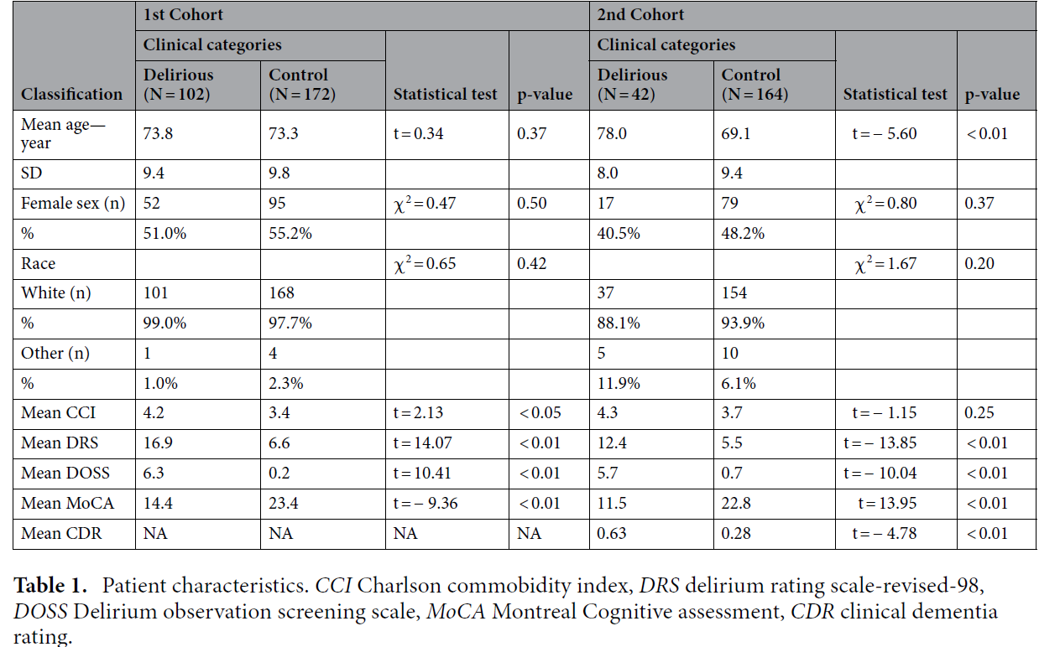

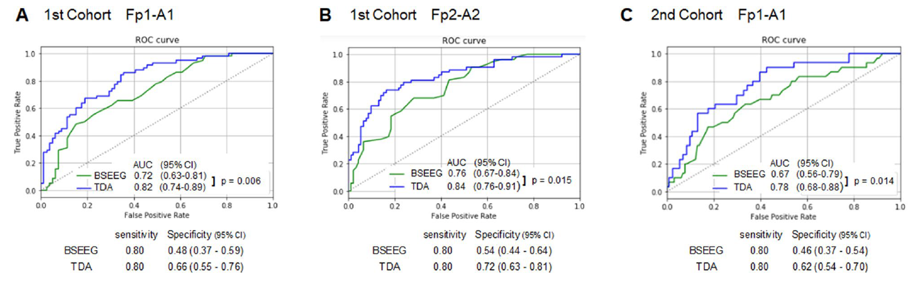
(A) ROC based on signals obtained from Fp1-A1 from the first cohort (58 delirium cases and 79 controls), (B) ROC based on signals obtained from Fp2-A2 from the first cohort (53 delirium cases and 92 controls), and (C) ROC based on signals obtained from Fp1-A1 from the second cohort (30 delirium cases and 131 controls). AUCs, DeLong’s test results, and specificities when sensitivities were set for 0.80 are shown.

Others:
Contact:
Amitkumar Shrivastava
Fujitsu Consulting India Private Limited (FCIPL)
Global Fujitsu Distinguished Engineer (AI) & Head of AI, AET, Applications
Fujitsu Fellow of Regional Fujitsu Distinguished Engineer (RFDE)
RFDE Head of GDU Chapter
Fujitsu Distinguished AI Ambassador, India

